INTERFACING FT5X06 WITH BEAGLEBONE

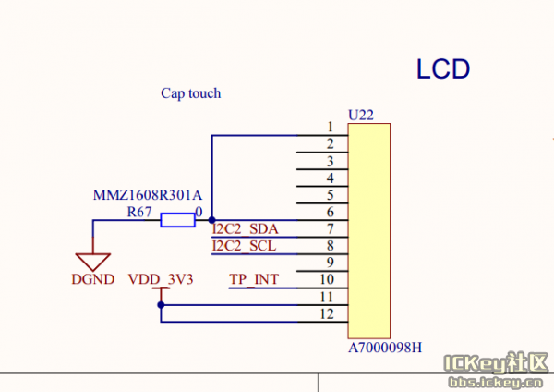

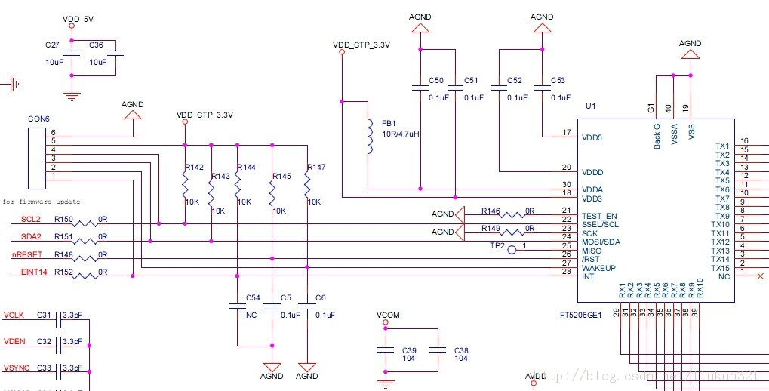

FT5X06 timing signals :

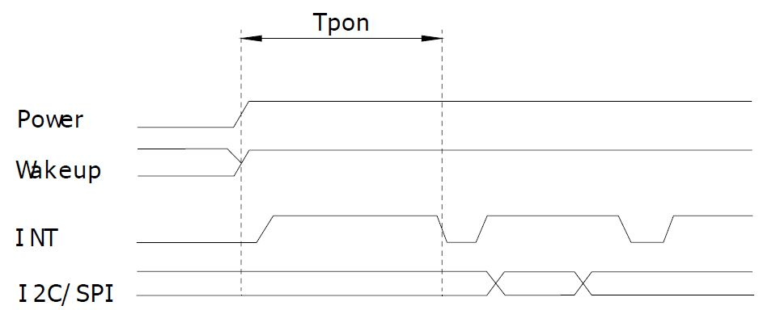

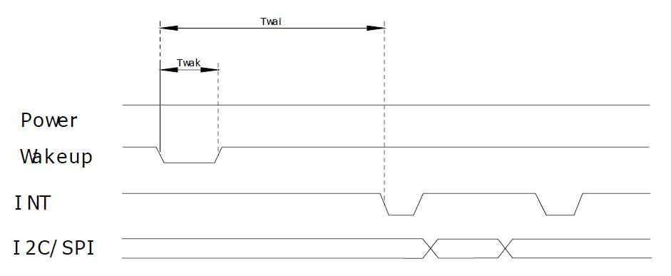

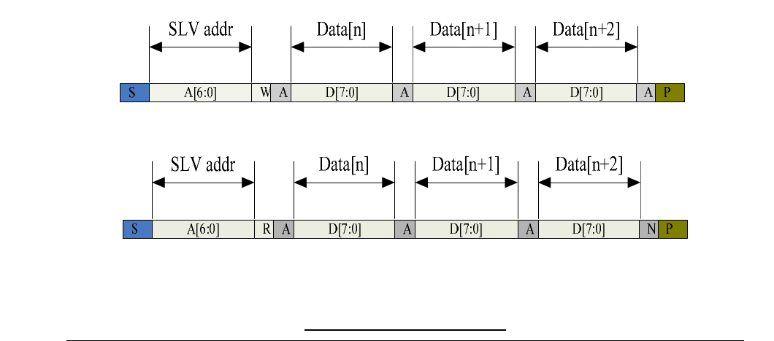
I2C INTERFACING :

CTPM interface to Host :

Figure 1-1 shows how CTPM communicates with the Host，there are three kind of communication between CTPM and Host，we will introduce each communication in this section.

Transfer the data via I²C

Send interrupt when there is a valid touch Host send Wakeup signal to CTPM
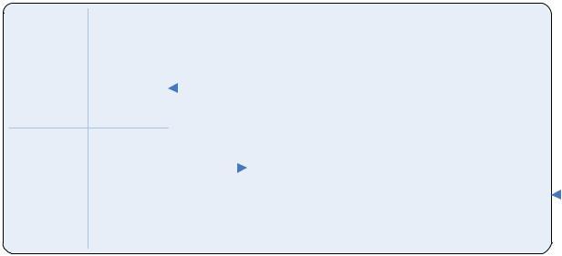
 |  |  |  |  |  |  |  |  |  |  |  |  |  |  |  |  |  |  |  |  |  |  |  |  |  | Serial
 |  |  |  |  |  |  |  |  |  |  |  |  |  |  |  |  |  |  |  |  |  |  |  |  | Interface
 |  |  |  |  |  |  |  |  |  |  |  |  |  | TX |  |  |  |  | CTP
 |  |  |  |  | CTP |  |  |  |  |  |  |  |  |  |  |  |  |  |  |  | MCU |  |  |  |  |  |  |  |  |  |  |  |  | Host
 |  |  |  |  | CTP |  |  |  |  |  |  |  |  |  |  |  |  |  | Controller |  | MCU |  |  |  |  |  | /INT |  |  |  |  |  |  | Host
 |  |  |  |  |  |  |  |  |  |  |  |  |  | RX
 |  |  |  |  |  |  |  |  |  |  |  |  |  |  |  |  |  |  |  |  |  |  |  |  |  | /WAKE
Figure 1-1 CTPM and Host connection

The Power Supply voltage of CTPM is 2.8V~3.3V, interface supply voltage is 2.8V~3.3V. There are Control Interface and Data Interface. As

Figure 1-1 demonstrates, Serial interface is the data interface, /INT and /WAKE are the control interface. For the detail, please refer to Table 1-1.
Table 1-1 Description for TP module and Host interface

Port Name | Voltage | Polar | Description
Serial | 2.8~3.3V |  | Serial interface is for data transfer between Host and CTPM.
interface |  |  | CTPM support both I2C and SPI interface
/INT | 2.8~3.3V | LOW | The interrupt from the CTPM to the Host
/WAKE* | 2.8~3.3V | LOW | Wakeup signal from host to the CTPM

I²C Read/Write Interface description :

Write N bytes to I2C slave

 |  |  | Slave Addr |  |  |  |  |  | Data Address[X] |  | Data [X] |  |  |  | Data [X+N-1]
S |  |  | A A A A A A A |  | R | A | R R R R R R R R |  |  | A | D D D D D D D D |  | A | … | D D D D D D D D | A | P
S |  |  | 6 5 4 3 2 1 0 |  | W | A |  |  | 7 6 5 4 3 2 1 0 | A | 7 6 5 4 3 2 | 1 0 | A | … | 7 6 5 4 3 2 1 0 | A | P
START |  |  |  |  | WRITEACK |  |  |  |  | ACK |  |  | ACK |  |  | ACKSTOP

Set Data Address
CTPM Application Note

 |  |  | Slave Addr |  |  |  |  | Data Address[X]
S |  |  | A A A A A A A | R | A | R R R R R R R R |  |  | A | P
S |  |  | 6 5 4 3 2 1 0 | W | A |  |  | 7 6 5 4 3 2 1 0 | A | P
START |  |  |  | WRITEACK |  |  |  |  | ACKSTOP

Read X bytes from I²C Slave

 | Slave Addr |  |  |  |  | Data [N] |  |  |  | Data [X+N-1]
S | A A A A A A A | R | A |  |  | D D D D D D D D |  | A | … | D D D D D D D D | A | P
 | 6 5 4 3 2 1 0 | W |  |  |  | 7 6 5 4 3 2 | 1 0 |  |  | 7 6 5 4 3 2 1 0
START |  | ReadACK |  |  |  |  |  | ACK |  |  | ACKSTOP

Interrupt signal from CTPM to Host :

As for standard CTPM, host need to use both interrupt control signal and serial data interface to get the touch data. There are two kind of method to use interrupt: interrupt trigger and interrupt query.

Here is the timing to get touch data.

Touch Start Touch End
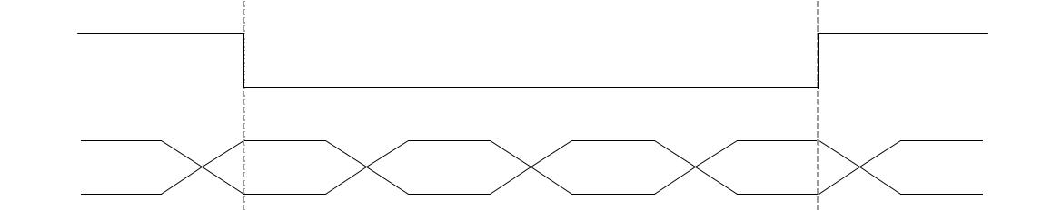
/INT

Serial
Data

Blank | Data Packet | Data Packet | …… | Data Packet | Blank
Blank | 0 | 1 | …… | N | Blank
 | Figure 1-2 Interrupt query mode
 | Touch Start |  |  | Touch End
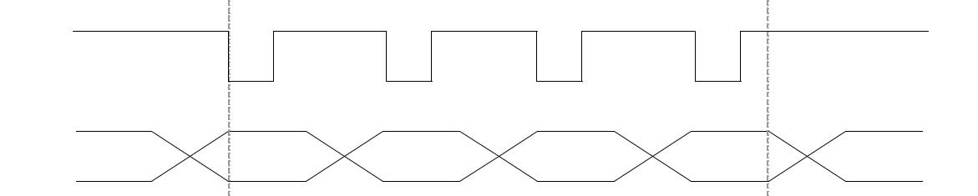
/INT

Serial
Data
Blank | Data Packet | Data Packet | …… | Data Packet | Blank
Blank | 0 | 1 | …… | N | Blank

Figure 1-3 Interrupt trigger mode

Host use general I2C protocol to read the touch data or the information from CTPM . CTPM will send host a interrupt signal when there is a valid touch. Then host can use the serial data interface to get the touch data. If there is no valid touch detected, the /INT will not be pulled up, the host do not need to read the touch data.

NOTE: “valid touch” may have different definition in various systems. For example, in some systems, the valid touch is defined as there is one more valid touch point. But in some other systems, the valid touch is defined as one more valid touch with valid gestures. In usual, /INT will be pulled up when there is a valid touch point, and to be low when a touch finishes.

As for interrupt trigger mode, /INT signal will be low if there is no touch detected. But for per update of valid touch data, CTPM will produce a valid pulse for /INT signal, host can read the touch data periodically according to the frequency of this pulse. In this mode, the pulse frequency is the touch data update frequency.
CTPM Application Note

.

Wakeup signal from Host to CTPM :

Host can use the Wakeup Signal to wakeup the I²C slave device.

This pin should be connected to GND when flash programming while in normal running mode it should not be connected to GND.

